5th International Summer School  of Pediatric Anaesthesiology  (ISSPA)  APPLICATION  Name_____________________________  Surname___________________________  Licence ___________________________  Adress____________________________  Post code_______City________________  State_____________________________  Phone_____________________________  Mobile____________________________  Fax______________________________  E-mail____________________________  Signature__________________________  Date______________________________  Registration for school sent to:  kontinuiranaedukacija@med.bg.ac.rs  FAX . +381 11 3636365  Tel . . +381 11 3636 364/3636363  Med.fak financial services. +381 11 36 36 314  Registration fee: 12.000 RSD  Continuing education  Faculty of Medicine, University of Belgrade  Doctor Subotica 8, Belgrade  Current account for payment: 840-1139666-89  Reference number. RP-377/1-742121  . RP-378/1-742121  VAT Medical School in BG: 100221404 | BELGRADE  UNIVERSITY SCHOOL  OF MEDICINE  International School of pediatric anesthesia  University Children`s hospital in Belgrade, Serbia  Association of Anesthesiologists and Intensivists of Serbia  International Anesthesia Teaching Center  Department of Anesthesiology and Resuscitation  School Director  Assoc. Prof. Dušica Simic  Organising Committee Chairperson  Dr. Miodrag Milenović  Organizacioni komitet  dr Sanja Trajković Jakovljević  dr Irina Milojević  dr Irena Nikolić Micović  dr Ivana Petrov Bojičić  dr Selena Pujić  dr Vladimir Stranjanac  КРЕДИТОВАН ОД СТРАНЕ ЗДРАКРЕДИТОВАН ОД СТРА Н Accreditation  A-1-641/13; A-1-644/13  153-02-562/2013-01  from 01.03 in 2013  Number of points : 13  Target Audience  doctors  СТВЕНОГ САВЕТА РЕПУБЛИИЈЕ | 5th International Summer School of Pediatric Anaesthesiology (ISSPA)    University Children's Hospital  Tirsova 10, Belgrade  May 24 – 25. 2013  Under the patronage of Ministry of Health of Serbia  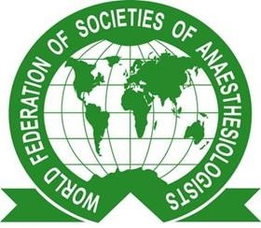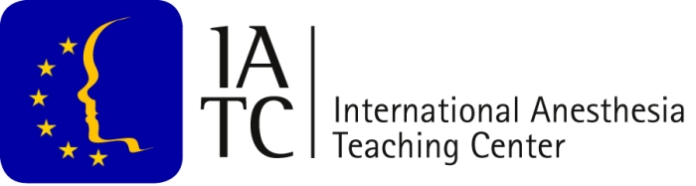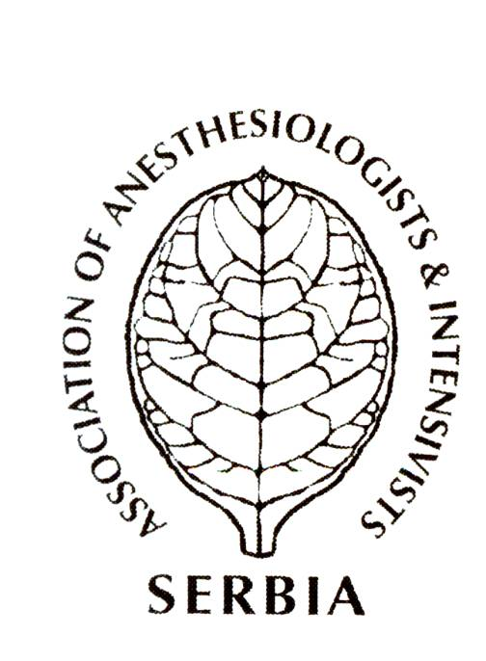  Praktični deo kursa  (demonstriranje na lutkama)  12.30 – 14.00  Pojedinačno vežbanje na fantom lutkama  ( uz demonstratore )  14.00-14.15 Pauza  14.15-15.45 Pojedinačno ocenjivanje  kvaliteta savladanih veština  na fantom lutkama  15.45-16.05 Testiranje učesnika  16.05-16.30 Dodela sertifikata

PROGRAM  Saturday May 24, 2013  08.30-9.00 Registration, Coffee  09.00-9.15 Welcome and introductory speech  09.15-09.30 Pre-test  09.30-10.00 Establishing a pediatric pain service  Markus Schily  Kinderklinik „Wildermeth“, Biel  Switzerland  10.00 -10.30 Chronic pain in children  Richard Howard  Great Ormond Street  Hospital for Children,  London, UK  10.30-11.00 Pediatric RA - update  Adrian Bosenberg  Seattle Children s Hospital,  Seattle, USA  11.00.-11.15 Coffee  11.15-11.45 Vaccination and anaesthesia  Walid Habre  Universitet hospital of Geneve  Switzerland  11.45-12.15 The approach to the syndromic child  Vesna Čolović  Manchester Children’s Hospitals, UK  12.15-12.45 Pro & Contra session  N₂O : is it needed anymore  10 min pro, 10 min contra, 10 min discussion  Nigel Turner and Walid Habre | 12.45-13.15 Pro & Contra session  IV or Inhalation anesthesia  10 min pro, 10 min contra, 10 min discussion  Martin Johr and Adrian Bosenberg  13.15-14.15 Case reports – interactive session  Branko Milaković, Ivana Budić,  Irina Milojević, Dušica Simić  14.15-15.00 Lunch  15.00- 16.30 Workshop  Ultrasound in RA  Adrian Bosenberg  Seattle Children s Hospital, USA  Irena Simić, UDK, Belgrade  16.30-18.00 Workshop  Teach the teachers  Ehrenfried Schindler and Nigel Turner  20.00 Gala dinner  Saturday May 25, 2013  9.00-09.30 Central venous access  in paediatric patients  – technique and pitfalls  Ehrenfried Schindler,  Department of Pediatric Anesthesiology  And Intensive Care Medicine, Congenital  Cardiac Center Sankt Augustin, Germany  09.30-10.00. The postoperative period  – avoiding problems  Martin Johr  Luzerner Kantonsspital Luzern  Switzerland | 10.00-10.30 Recent developments and controversies an  pediatric resuscitation  Nigel Turner  UMC Utrecht, Netherlands  10.30-11.00 Implementing team based training  Ralph Mackinnon  Royal Manchester Children’s Hospital,  Manchester, UK  11.00-11.20 Coffee  11.20-11.50 Pro & Contra session  Albumin ( golden rule or poison )  10 min pro, 10 min.cotra, 10 min disusion  Vesna Čolović and Ralph Mackinnon  11.50-12.20 Pro & Contra session  Paediatric resuscitation with air or O₂  10 min pro, 10 min.cotra, 10 min disusion  Biljana Drašković and Darko Golić  12.50-13.50 Case reports – interactive session  Mladen Erceg, Marija Marković,  Miloš Petković, Gradimir Korać  13.50-14.30 Lunch  14.30-16.00 Workshop  Simulation  Ralph Mackinnon, Ivana Petrov Bojičić  16.00-17.00 Workshop  IO line  Sanja Trajković Jakovljević  Vesna Stevanović  17.00- 17.15 Post-test  17.15- 17.45 Certificate Handover Ceremony  (With cakes and coffee)

